International Elephant Foundation’s Elephant Conservation and Research Funding Support Program

Sample - Draft Application

Please note: This Word.doc file is to help you as you complete your Grant Application.

We STRONGLY SUGGEST that you use this file to prepare and compose your answers and then copy and paste your information into the application.

- The application is lengthy
- The majority of all questions are required
- A number of file uploads are required
- If you lose internet connection during input and don’t have your answers on a backup document it could be very time consuming to re-input everything from scratch.
- Composing your answers on this draft document allows you to revisit/revise your answers prior to final submission.

This file is created March 30, 2025 – we do not anticipate changes to the application – which is due no later than August 1, 2025, but circumstances may require an edit here or there – thus please take care when you are transferring your answers from the working file to the online application to make sure the question and detail match.

Criteria for funding
To guide you in your project submission, the following criteria have been established:
IEF prefers to support annual and multi-year projects that address:
- Human-Elephant Conflict prevention and mitigation
- Habitat conservation and management;
- Conservation education and community outreach;
- Transfrontier or transboundary elephant conservation;
- Elephant protection programs including anti-poaching patrols, infra-structure development, security, investigation and prosecution;
- Reducing and preventing the ivory and bushmeat trade; and
- Research into elephant diseases.
Before you begin to write your proposal, consider that IEF prefers to fund:
- Community-based programs that show promise for future growth;
- Projects that have an immediate and measurable effect on elephant conservation;
- Projects that can be accomplished and their success initially evaluated within a year, or two years if the proposal indicates a longer timeframe;
- Project investigators’ CV demonstrates experience or a strong indication of their ability to be successful; and
- Project investigator has established field-based operations in the project area.
As you prepare your budget, these are some items that IEF will not fund:
- Out of country travel to project site;
- Purchase of guns and ammunition;
- Paid informants;
- Tuition fees for Advanced Degrees; and
- Overhead, indirect, contingency, and miscellaneous costs.
Files that you are expected to upload:
(Type) / Description
(image) / Country Project Location
(image) / Specific Project Location
(image) / Elephant(s) in Project Location
(document) / Copy of Organization/Entity Country Recognition – if appropriate
(document) / Investigator and Co-Investigator(s) CV
(document) / Permit(s), Letter(s), Endorsement(s)
(document) / Permits or IACUC – if appropriate

PROJECT OVERVIEW
Project Title
 | Provide your title in 10 words or less
Location:
 | Provide the Country and Region or Landscape within the Country
Is your project in INDIA?
 | Yes (if you select “Yes” see next item)
Projects in INDIA. (please check box)
(you will need to check the box)

I understand and agree to the policy and will be providing the proper documentation. I understand that no funding will be forthcoming without that evidence and support.
COUNTRY PROJECT Location
(Attach a Map of the Country where the Project is located.)
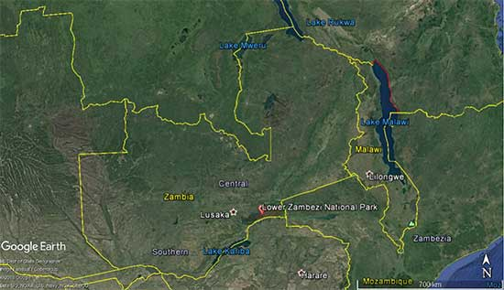

SPECIFIC PROJECT Location
(Attach a Map of the SPECIFIC Location where the project is located within the Country.)
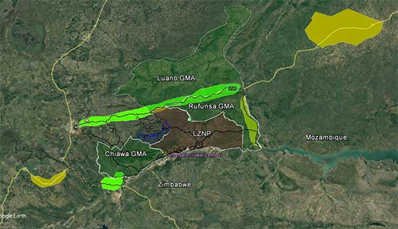

Elephant species that is the focus of the project activities:
(Select at least one: Asian, African savannah, African forest)
Asian, _____. African Savannah. _____, and African Forest. _________
Attach a recent photo of an elephant or elephants found in the area where project activities will occur.
 | Upload a recent photo
Project Start Date
Input your project start date

MM / DD / YYYY
Project End Date
Input your project end date

MM / DD / YYYY

Is this project currently ongoing?
 | Yes (see next question). No (no additional info needed)
Previously Started or Continuation Project Details
 | If yes, (Please provide a brief summary on project details, max 100 words)
BUDGET SUMMARY
Total Project Budget
Input total project budget

$
Total Requested from the International Elephant Foundation
Input total requested from IEF

$
PRINCIPAL INVESTIGATOR
Principal Investigator
 | First Name, Last Name
Title Your Phone
 | Title, Phone Number
Your Email. (twice for confirmation)
 | Email Address Confirming Email Address
Institution
 | Institution Name (or if none add NA).
Institution Address (add address if Institution added above)

Website URL. (add Website URL if applicable)

Social Media Accounts. (URLs for FB, L-I and YT), Handles for Ig, X, TT, etc

Required Field – Add all accounts
(Facebook, X, website URLs, etc)

CO-INVESTIGATORS
Add a Co-Investigator? “Yes” will open entry; “No” will skip fields
You will be able to add up to 3 Co-Investigators. Questions are identical to Investigator.

- Name, Title, Phone, Email, Institution, Address, Website, Social Accounts

- Name, Title, Phone, Email, Institution, Address, Website, Social Accounts

- Name, Title, Phone, Email, Institution, Address, Website, Social Accounts

PREVIOUS IEF AWARDS
Have you previously received grants from IEF?
Yes (you will be able to add additional rows for multiple grant awards). (If no fields are hidden)

Please list ALL previous IEF grants received by Principal Investigator, Co-Investigators, or related institution. Include year of award, Investigator name, project title, country, and award amount.
Previous IEF Grant Awards.
 | Year Investigator Name Project Title Country Amount
Previous Awarded Project Details. (max 200 words)
TELL US ABOUT YOURSELF
Do you or your organization have permanent field-based operations in the community where the project activities will occur?

 | If you answer “Yes” the following 2 questions will appear.
- How many years have you or the field-based community been operating?
- Briefly describe your field-based activities. (max 150 words)
If you answer “No” to the previous question, you will be asked:

Why did you choose this specific location?

What is your relationship to the project site?

How frequently have you visited the project site?

Do you have local partners with ties to the project site?

Are you or your organization a registered conservation entity recognized by the government of the country in which the project will take place?
 | If you answer “Yes” you will be asked to upload a copy of your or your organization's registration.
 | If you answer “No” is the registration pending?
If you answered “YES” - Please upload a copy of your or your organization's registration
 | Upload file.
PROJECT SUMMARY
Provide a detailed summary of your project’s goals and activities that we can use in promoting your project. Please make sure to indicate the current status of the elephant population as well as key threats your actions will project is addressing. (max 250 words)
Briefly describe key methods and activities you plan to implement to achieve project goals. (max 200 words)
PROJECT NARRATIVE
Background and context that justifies the need for your project. (max 1500 words)
Describe what you believe is most important about the project and how your work will benefit the specific elephants, habitat, other wildlife and human communities. (max 200 words)
Explain if this is a new approach being proposed and why you think it will be successful. If not, explain how it has been used elsewhere and list similar projects and locations used as models, cite the pertinent literature or include documentation. (max 500 words)
How does this proposal fit into your future elephant conservation plans? (max 150 words)
GOALS & OBJECTIVES. (You are allowed to add up to 5 Goals)
First Goal (max 40 words)
Objective. You are allowed to add multiple objectives per goal (max 40 words per goal)
ACTIVITIES. (You are allowed to add up to Activities per each Goal)
Activity Title. (max 40 words)
Activity Explanation & Responsibility. (Max 190 words) We suggest 150 words for Activity Explanation and 40 words for Who will be Responsible)
Title:
Explanation: Responsibility:

Include a Second Goal?
To add a second, third, fourth, and fifth Goal you would select “Yes” and the new set of questions will appear. To assist – the next four pages simulate additional Goals if you will be adding more than one.

ADDITIONAL GOALS & OBJECTIVES.

SECOND Goal (max 40 words)

Objective. You are allowed to add multiple objectives per goal (max 40 words per goal)

ACTIVITIES. (You are allowed to add up to Activities per each Goal)

Activity Title. (max 40 words)
Activity Explanation & Responsibility. (Max 190 words) We suggest 150 words for Activity Explanation and 40 words for Who will be Responsible)

Title:

Explanation: Responsibility:

Include a Third Goal?

ADDITIONAL GOALS & OBJECTIVES.

THIRD Goal (max 40 words)

Objective. You are allowed to add multiple objectives per goal (max 40 words per goal)

ACTIVITIES. (You are allowed to add up to Activities per each Goal)

Activity Title. (max 40 words)
Activity Explanation & Responsibility. (Max 190 words) We suggest 150 words for Activity Explanation and 40 words for Who will be Responsible)

Title:

Explanation: Responsibility:

Include a Fourth Goal?

ADDITIONAL GOALS & OBJECTIVES.

FOURTH Goal (max 40 words)

Objective. You are allowed to add multiple objectives per goal (max 40 words per goal)

ACTIVITIES. (You are allowed to add up to Activities per each Goal)

Activity Title. (max 40 words)
Activity Explanation & Responsibility. (Max 190 words) We suggest 150 words for Activity Explanation and 40 words for Who will be Responsible)

Title:

Explanation: Responsibility:

Include a Fifth Goal?

ADDITIONAL GOALS & OBJECTIVES.

FIFTH Goal (max 40 words)

Objective. You are allowed to add multiple objectives per goal (max 40 words per goal)

ACTIVITIES. (You are allowed to add up to Activities per each Goal)

Activity Title. (max 40 words)
Activity Explanation & Responsibility. (Max 190 words) We suggest 150 words for Activity Explanation and 40 words for Who will be Responsible)

Title:

Explanation: Responsibility:

PROJECT TIMETABLE.
You must add at least ONE activity AND Put an X on the month(s) the activity will occur
Timetable Activity

NOTE: To add Activity/Activities, you will click the “Add Activity” button, a pop up box will appear for your data.
Please add each Activity individually.
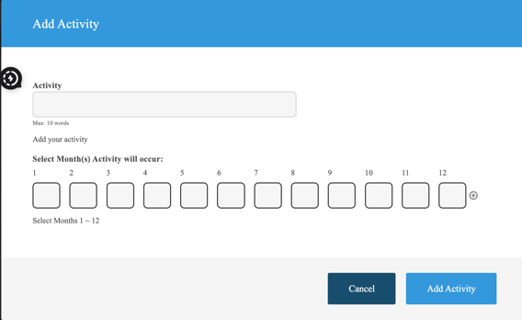

Once the Activity has been added you will see that you can
edit or delete it at any time BEFORE you Submit your application.
Activity
Add the Activity Name in the text box and the month(s) it will occur in the months box below as shown
Select Month(s) Activity will occur:
1 | 2 | 3 | 4 | 5 | 6 | 7 | 8 | 9 | 10 | 11 | 12
x |  |  | x |  |  |  | x |  |  |  | x

Multiple activities is simulated below:
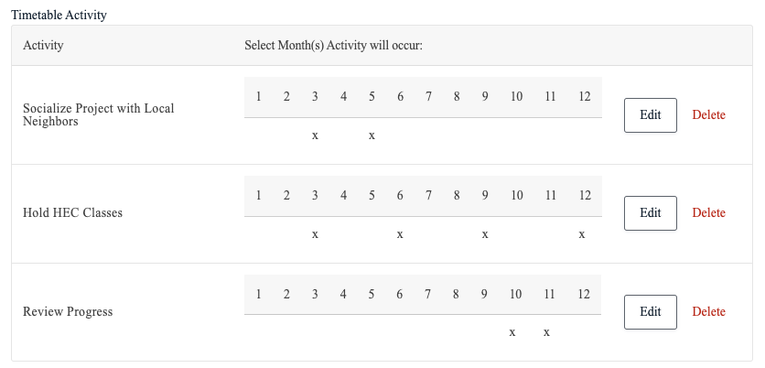

PROJECT MONITORING and EVALUATION
What will you measure to determine the effectiveness of your project activities and methods in addressing those needs. How will you measure it during operation of the project, and at the end of the project? (max 200 words)
Identify if and how project participants and beneficiaries will participate in monitoring and evaluation activities (max 200 words)
Describe how findings will contribute to decision making and project activities during and after the project period. (max 200 words)
Identify how you will determine the degree of success of the project. (max 200 words)
Identify how the results may be used by others. (max 200 words)
SUSTAINABILITY
Identify which project activities will continue beyond the proposed project period
 | .
Describe how the results will continue to support project goals and the conservation of elephants beyond the grant period.
 | .
What is needed for the project to become sustainable long term?
 | .
Who will continue the work or act on the results achieved?
.

Indicate how your plan(s) to carry out the project goals would change with extenuating circumstances. If these circumstances may be unique to your project location, please describe them. (max 500 words).

SAFEGUARDING
Do you have a safeguard policy for protecting local communities? Please provide details. (max 100 words)
 | .
Do you have a code of conduct and/or guidelines for staff? Please provide details. (max 100 words)
 | .
Do you have a risk management or assessment process to identify and mitigate any potential risks? Please provide details. (max 100 words)
 | .
BUDGET

must be in US currency, itemized and divided into the following categories. Budget requests that consist primarily of salary or travel will generally not be considered favorably, and will only be considered for residents of the elephant range state where the work is occurring.

* project personnel (stipends or salary support, number of persons, hours, rate, position),
* travel expenses (number of persons, cost per trip, number of trips),
* lodging and meals (numbers of days x persons),
* activity (itemize)
* equipment (itemize)
* supplies (itemize)
* services (itemize)
* miscellaneous expenses (itemize)

IEF will not fund overhead, indirect, contingency, or indirect costs. IEF will not fund armaments and ammunition, paid informants, tuition fees for Advanced Degrees, and in most cases out of country travel to the project site.

The following sample budget format must be used. Price per unit must be included for each relevant line item.

Click the "+" button at the right of the row on the online form to add an additional row/item.

Itemized Calculation:
Describe the item in the first field. The calculation field should contain the per unit cost, the quantity required and if needed an additional multiplier if ordering the per item in quantity for additional sets or groups (please see example below).

SAMPLE Budget Item Details

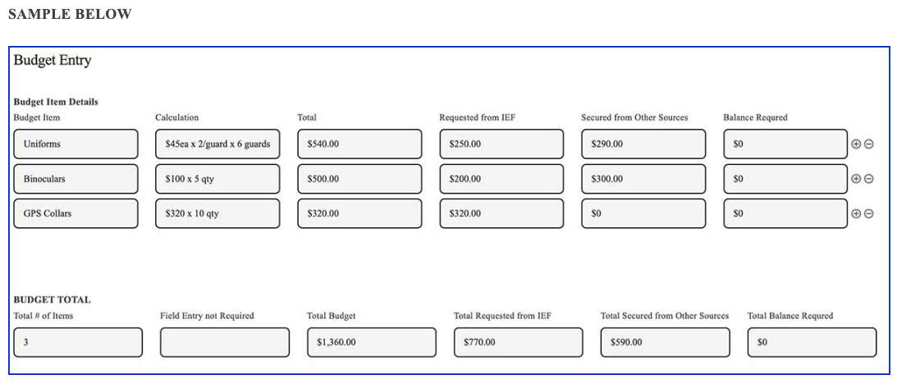
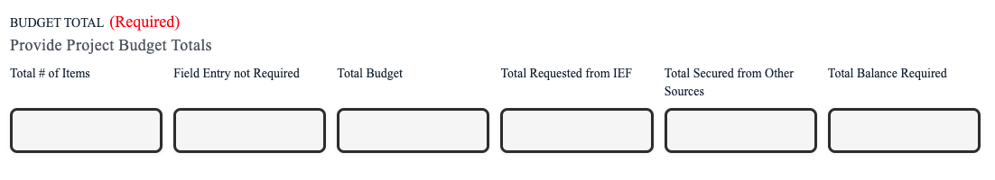

Prioritization of Budget Items

Rank the budget items listed using the numbers 1~10 or 1~20 (depending on the number of budget item listed with “1” being the most important to fund and ensuring that each number is only used once.
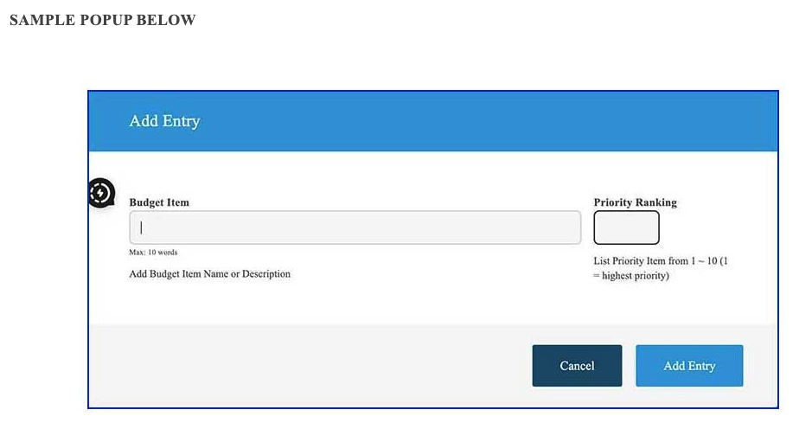 | SAMPLE POP UP  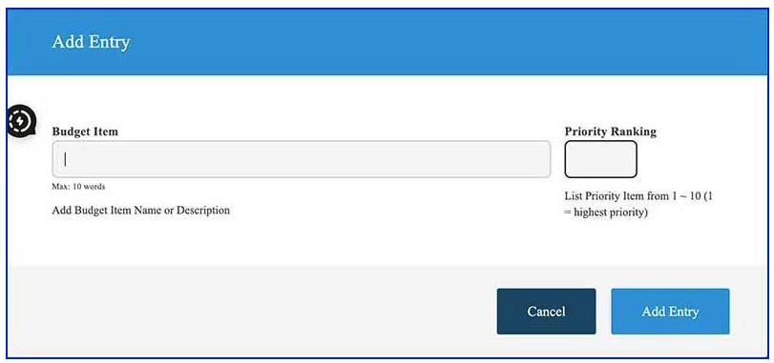  Budget Item Ranking  EACH NUMBER MAY ONLY BE USED ONCE  Upon selecting the "Add Entry" button, the form will start with the "Number 1" priority - if this is not your first priority either select a different number or change the Budget Item text to your Priority 1 BEFORE completing the entry item.
Project Total
Justify each Budget Item. (max 500 words)
 | .
Alternative Sources/Options

Describe what alternatives you have if the project is not selected or if it is not awarded the full amount you are requesting from IEF. You may consider listing the funding sources you have already secured. (max 100 words)
 | .
QUALIFICATIONS OF PRINCIPAL and CO-INVESTIGATIONS
Provide a brief description of the applicant organization and all participating entities and/or individuals. Describe the specific personnel who will complete each project activity and describe their roles. (maz 1000 words)
 | .
UPLOAD EACH INDIVIDUAL'S CV

Please upload each individual’s CV

----------------------------------------------------------------------------------------------------------------------

PERMITS, LETTERS of SUPPORT and/or COOPERATION and GOVERNMENT ENDORSEMENT

Please provide all documentation (e.g., permits, letters of support, government endorsement) that is necessary to carry out your work. If you do not have documentation, please provide specific information about how and when you will obtain that documentation.

Documentation is mandatory and must be uploaded.
Upload Documents (permits, letters, endorsements)
 | Upload is required.
LITERATURE CITED

If cited, you must provide full citations for all of references listed within the text of the project narrative.
 | .
IACUC

Indicate whether PERMITS or IACUC (Institutional Animal Care and Use Committee) approval (where required for the study) have been obtained. An Institutional Animal Care and Use Committee (IACUC) approval is required whenever research, testing, or teaching activities involve the use of live vertebrate animals. This includes studies funded by Public Health Service (PHS) agencies or other organizations that mandate compliance with animal welfare regulations. The IACUC ensures that the proposed activities are ethical, minimize animal discomfort, and adhere to established guidelines for humane care and use of animals.
 | If you answer “Yes” please upload documents, if “No” answer if approval is pending, if “N/A” no answer required.
Upload Documents (permits and/or approvals)
Terms & Conditions for 2025 Grant Proposals. (details below)
 | By clicking this box the applicant affirms:

Terms & Conditions for 2026 Grant Proposals

My proposed project for which I am submitting this application:

fully adheres to the International Elephant Foundation policies and guidelines as outlined in this application, and

fully adheres to all relevant international, national, and/or state guidelines, policies, and regulations governing its implementation.

I have thoroughly reviewed and familiarized myself with the applicable laws, regulations, and administrative policies pertaining to the proposed project, and I am committed to ensuring strict compliance with these requirements throughout all stages of the project.

I understand that any deviation from international, national, and/or state guidelines or policies could result in legal consequences, financial penalties, or the suspension/termination of the project.

I acknowledge that it is my responsibility to stay informed about any updates or changes to international, national, and/or state guidelines or policies that may impact the proposed project and to promptly adjust project activities to remain in compliance.

I am fully committed to upholding and respecting human rights as outlined in international law, including but not limited to the Universal Declaration of Human Rights and relevant conventions and treaties.

I have not been involved, directly or indirectly, in any activities that violate human rights, including but not limited to acts of discrimination, harassment, exploitation, or violence against any individual or group based on race, ethnicity, nationality, religion, gender, sexual orientation, disability, or any other characteristic protected under international human rights law.

I have not been affiliated with any organizations or entities that have been found to engage in human rights abuses or violations, nor have I provided support, financial or otherwise, to such organizations or entities.

I will not to make, publish, or communicate to any person or entity any disparaging, negative, or derogatory remarks, comments, or statements about the International Elephant Foundation, its subsidiaries, affiliates, officers, directors, employees, products, services, or policies.

Failure to comply with these terms and conditions may result in the termination of an open grant awards, immediate disqualification from consideration, and legal action as deemed appropriate by the grantor.

